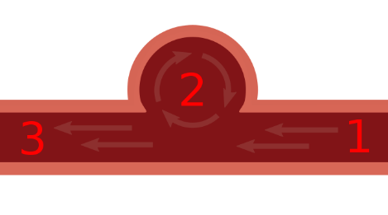

Blood swirls in aneurysm, causing clotting

Clot may leave aneurysm and block vessel elsewhere