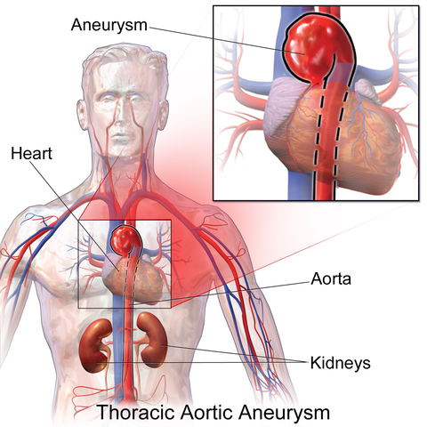

Aortic aneurysm pushing on and compressing the esophagus inhibits swallowing.

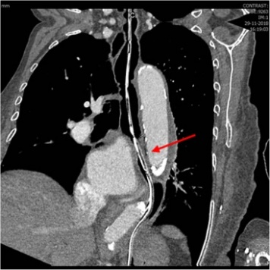

Esophagus (open)

Esophagus (open)

Aneurysm compressing esophagus

Aneurysm