**Fig. 10.1 The digestive system. (Sources of images and videos below. Used with permission.)**

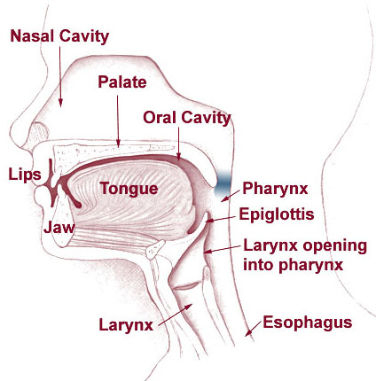

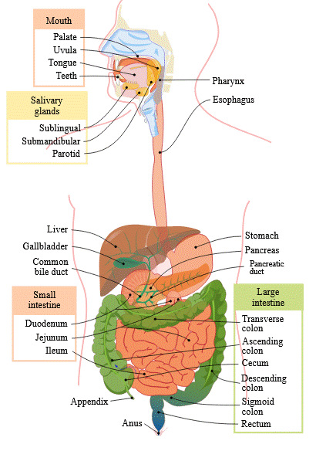

**Videos**

# “Digestion”

<https://blausen.com/en/video/digestive-system/>

# “Digestive System”

<https://blausen.com/en/video/digestive-system/>

# “Gastrointestinal Tract”

<https://blausen.com/en/video/gastrointestinal-tract/>

NOTE: WASTE is expelled, not food.

# “Tooth Anatomy”

<https://blausen.com/en/video/tooth-anatomy/>

# “Mastication”

<https://blausen.com/en/video/mastication/>

# “Salivary Glands”

<https://blausen.com/en/video/salivary-glands/>

# “The Pharynx”

<https://blausen.com/en/video/the-pharynx/>

# “The Esophagus”

<https://blausen.com/en/video/the-esophagus/>

# “Deglutition”

<https://blausen.com/en/video/deglutition/>

# “Enzymes”

<https://blausen.com/en/video/enzymes/>

# “Absorptive and Postabsorptive States”

<https://blausen.com/en/video/absorptive-and-postabsorptive-states/>

# “Appendicitis”

<https://blausen.com/en/video/appendicitis/>

# “Colon Cancer”

<https://blausen.com/en/video/colon-cancer/>

# “Liver Function”

<https://blausen.com/en/video/liver-function/>

“Hepatitis”

<https://blausen.com/en/video/hepatitis/>

# “Liver Cirrhosis”

<https://blausen.com/en/video/liver-cirrhosis/>

# “Vitamins and Minerals”

<https://blausen.com/en/video/vitamins-and-minerals/>

Copyright 2020: Augustine G. DiGiovanna, Ph.D., Salisbury, Maryland  
The materials on this site are licensed under CC BY-NC-SA 4.0 .

<https://www.biologyofhumanaging.com/Figures/CC-BY-NS-SA%20image.jpg>   
Attribution-NonCommercial-ShareAlike

This license requires that reusers give credit to the creator. It allows reusers to distribute, remix, adapt, and build upon the material in any medium or format, for noncommercial purposes only. If others modify or adapt the material, they must license the modified material under identical terms.   
Previous print editions of the text Human Aging: Biological Perspectives are © Copyright 2000, 1994 by The McGraw-Hill Companies, Inc. and 2020 by Augustine DiGiovanna.

[View License Deed](https://creativecommons.org/licenses/by-nc-sa/4.0) | [View Legal Code](https://creativecommons.org/licenses/by-nc-sa/4.0/legalcode)

**Sources of images and videos. Used with permission.**

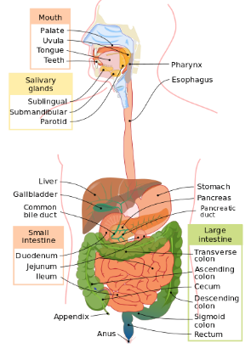

<https://commons.wikimedia.org/wiki/File:Digestive_system_diagram_en.svg>

Description **English:** The [**gastrointestinal tract**](https://en.wikipedia.org/wiki/gastrointestinal_tract), also called the digestive tract, alimentary canal, or gut, is the system of organs within multicellular animals that takes in food, digests it to extract energy and nutrients, and expels the remaining waste.

Date 17 December 2006

Source Own work

Author [Mariana Ruiz](https://commons.wikimedia.org/wiki/User:LadyofHats), [Jmarchn](https://commons.wikimedia.org/wiki/User:Jmarchn)

Permission  
([Reusing this file](https://commons.wikimedia.org/wiki/Commons:Reusing_content_outside_Wikimedia)) This work has been released into the [**public domain**](https://en.wikipedia.org/wiki/en:public_domain) by its author, [**LadyofHats**](https://commons.wikimedia.org/wiki/User:LadyofHats). This applies worldwide.

In some countries this may not be legally possible; if so:  
[*LadyofHats*](https://commons.wikimedia.org/wiki/User:LadyofHats) *grants anyone the right to use this work* ***for any purpose****, without any conditions, unless such conditions are required by law.*

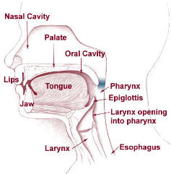

<https://commons.wikimedia.org/wiki/File:Head_neck_vsphincter.png>

Description Head and Neck Overview (from <http://training.seer.cancer.gov/head-neck/anatomy/overview.html>)

Date 31 May 2012, 16:21 (UTC)

Source This file was derived from: [Illu01 head neck.jpg](https://commons.wikimedia.org/wiki/File:Illu01_head_neck.jpg):

* Author [Illu01_head_neck.jpg](https://commons.wikimedia.org/wiki/File:Illu01_head_neck.jpg): [Arcadian](https://commons.wikimedia.org/wiki/User:Arcadian)
* derivative work: [Prof. Squirrel](https://commons.wikimedia.org/wiki/User:Prof._Squirrel)

This is a [***retouched picture***](https://en.wikipedia.org/wiki/Image_editing), which means that it has been digitally altered from its original version. Modifications: *Highlighted velopharyngeal sphincter*. The original can be viewed here: [**Illu01 head neck.jpg**](https://commons.wikimedia.org/wiki/File:Illu01_head_neck.jpg)**: [](https://commons.wikimedia.org/wiki/File:Illu01_head_neck.jpg)**. Modifications made by [Prof. Squirrel](https://commons.wikimedia.org/wiki/User:Prof._Squirrel).

## Licensing

This work is in the [**public domain**](https://en.wikipedia.org/wiki/en:Public_domain) in the United States because it is a [work prepared by an officer or employee of the United States Government as part of that person’s official duties](https://en.wikipedia.org/wiki/en:Copyright_status_of_work_by_the_U.S._government) under the terms of [*Title 17, Chapter 1, Section 105*](https://en.wikisource.org/wiki/en:United_States_Code/Title_17/Chapter_1/Sections_105_and_106) *of the* [*US Code*](https://en.wikipedia.org/wiki/United_States_Code). **Note: This only applies to original works of the Federal Government and not to the work of any individual** [**U.S. state**](https://en.wikipedia.org/wiki/U.S._state)**,** [**territory**](https://en.wikipedia.org/wiki/United_States_Territory)**, commonwealth, county, municipality, or any other subdivision. This template also does not apply to postage stamp designs published by the** [**United States Postal Service**](https://en.wikipedia.org/wiki/United_States_Postal_Service)[**since 1978**](https://commons.wikimedia.org/wiki/Stamps_of_the_United_States#Copyright-Note_up_to_1978)**. (See §** [**313.6(C)(1)**](https://copyright.gov/comp3/chap300/ch300-copyrightable-authorship.pdf) **of Compendium of U.S. Copyright Office Practices). It also does not apply to certain US coins; see** [**The US Mint Terms of Use**](https://www.usmint.gov/policies/terms-of-use)**.**

[This file has been identified as being free of known restrictions under copyright law, including all related and neighboring rights.](https://creativecommons.org/publicdomain/mark/1.0/deed.en)

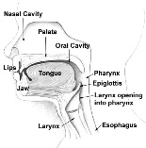

<https://commons.wikimedia.org/wiki/File:Illu01_head_neck.jpg>

Description **English:** Head and Neck Overview

Date 15 February 2007

Source <http://training.seer.cancer.gov/head-neck/anatomy/overview.html>

Author [Arcadian](https://commons.wikimedia.org/wiki/User:Arcadian)

## Licensing

*This image is a work of the* [***Centers for Disease Control and Prevention***](https://en.wikipedia.org/wiki/en:Centers_for_Disease_Control_and_Prevention)*, part of the* [***United States Department of Health and Human Services***](https://en.wikipedia.org/wiki/en:United_States_Department_of_Health_and_Human_Services)*, taken or made as part of an employee's official duties. As a work of the* [*U.S. federal government*](https://en.wikipedia.org/wiki/Federal_Government_of_the_United_States)*, the image is in the* [***public domain***](https://en.wikipedia.org/wiki/public_domain)*.*

**Videos**

# “Digestion”

<https://blausen.com/en/video/digestive-system/>

# “Digestive System”

<https://blausen.com/en/video/digestive-system/>

# “Gastrointestinal Tract”

<https://blausen.com/en/video/gastrointestinal-tract/>

NOTE: WASTE is expelled, not food.

# “Tooth Anatomy”

<https://blausen.com/en/video/tooth-anatomy/>

# “Mastication”

<https://blausen.com/en/video/mastication/>

# “Salivary Glands”

<https://blausen.com/en/video/salivary-glands/>

# “The Pharynx”

<https://blausen.com/en/video/the-pharynx/>

# “The Esophagus”

<https://blausen.com/en/video/the-esophagus/>

# “Deglutition”

<https://blausen.com/en/video/deglutition/>

# “Enzymes”

<https://blausen.com/en/video/enzymes/>

# “Absorptive and Postabsorptive States”

<https://blausen.com/en/video/absorptive-and-postabsorptive-states/>

# “Appendicitis”

<https://blausen.com/en/video/appendicitis/>

# “Colon Cancer”

<https://blausen.com/en/video/colon-cancer/>

# “Liver Function”

<https://blausen.com/en/video/liver-function/>

“Hepatitis”

<https://blausen.com/en/video/hepatitis/>

# “Liver Cirrhosis”

<https://blausen.com/en/video/liver-cirrhosis/>

# “Vitamins and Minerals”

<https://blausen.com/en/video/vitamins-and-minerals/>